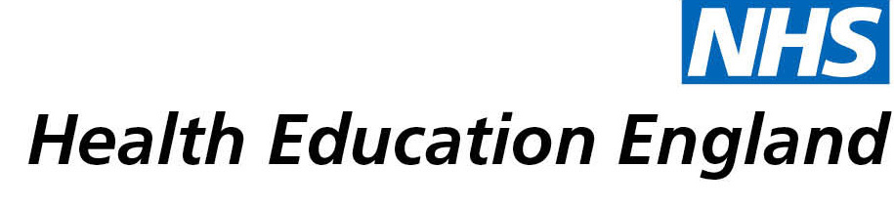

# *Improving services for people with Profound and Multiple Learning Disabilities (PMLD). Current Awareness and Table of Contents Services*

# *Oxford Health Libraries*

Date: *10th May 2021*

## Reason for enquiry

## The evidence is clear that People with Profound and Multiple Learning Disabilities (PMLD) get poorer services and poorer access to services

## What the knowledge and library specialist did

# Mark Bryant, the outreach librarian provides regular tailored alerts that are specifically focused on the needs of the OHFT Learning Disabilities team covering topics such as Intensive Interaction and our team is able to make use of the evidence provided to improve services for people with PMLD

# Impact of input from the library and knowledge service

*[General Comments]*

## Immediate Impact

My colleague and I have used the literature from PMLD alerts to argue for and set up a proactive project in the Intensive Interaction service that should provide ongoing monitoring of their needs and faster access to intervention if needed.

## Probable future Impact

“Services for people with PMLD are improved because I am better informed as a clinician”

## Name and Job Title:

“As a result of the ideas generated from the alerts, service users will get a better multidisciplinary service because of improved team formulation”

Name: Julie Elsworth

Job Title: Clinical Psychologist

Trust/Employing body: Oxford Health

## For further information on how you can get similar support contact your local NHS library and knowledge service.